**Cng 352**

**Assignment 2**

**Raed Alsheikh Amin 2528271**

***Note:*** MySQL workbench is used.

***1) Create an account called DreamDBA and create the Staff relation and the views specified above with this account. In your report, you need to include the relevant SQL queries, explain your response and you need to also include screenshots to demonstrate that you run the relevant queries.***

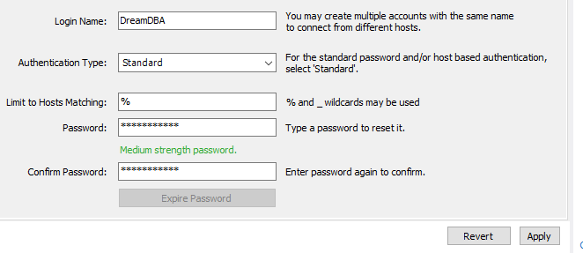

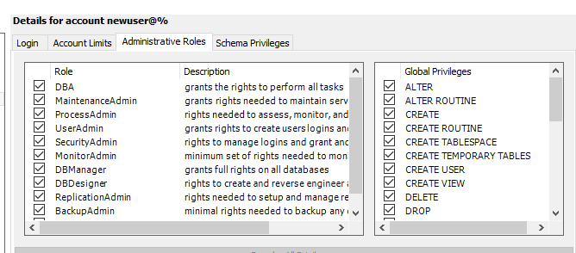  
all privileges are given.

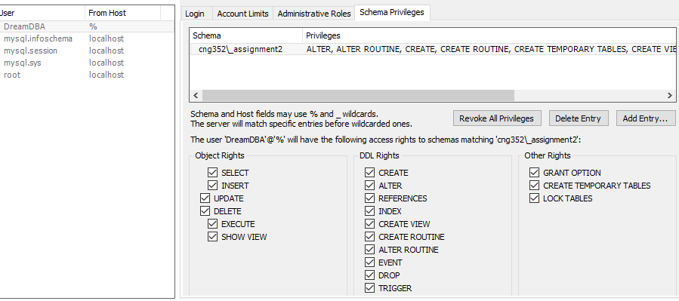

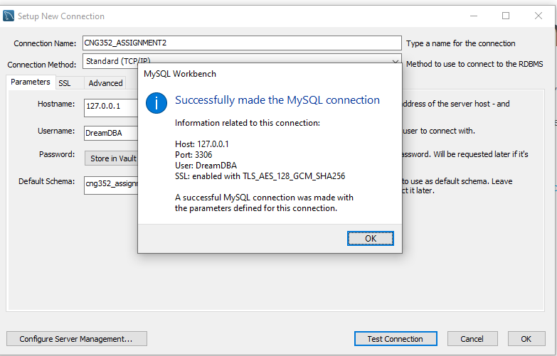

create table  
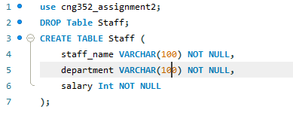

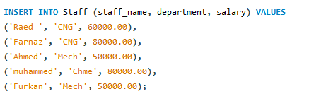  
-> select * from staff;  
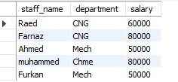

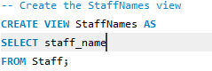

->SELECT * FROM StaffNames;

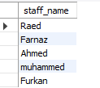

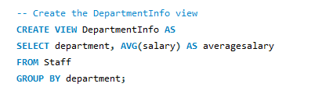

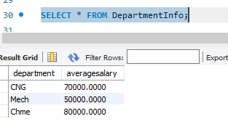

***2)Create another account called passiveUser such that he can only see the average department salaries.***

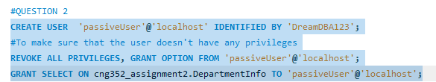

To check what the user has access to.

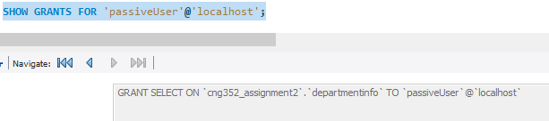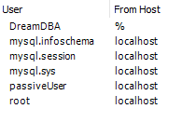

We can see that passiveUser is created  
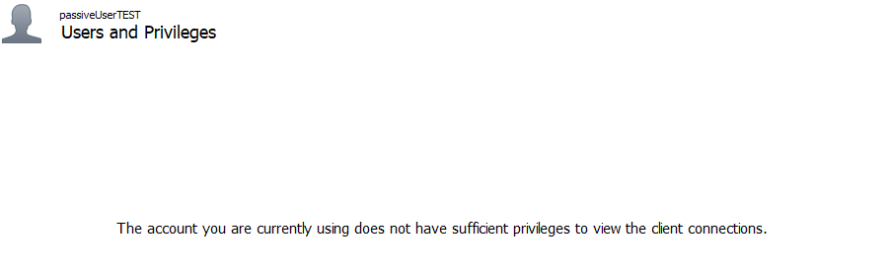

Now we can test it in (passiveuser connection)

->SELECT * FROM DepartmentInfo;  
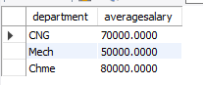

SELECT * FROM Staff;  
  
  
we can see it got denied.

***3)Imagine that in your database you have information about two departments called CNG and MECH. What privileges should be granted to passiveUser if he needs to know only average department salaries for the CNG and MECH departments?***

NOTE: CNG and MECH are other departments, but the idea is the same

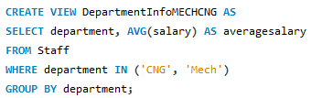  
we create a view that has only the info we need for passiveuser to access

-> select * from DepartmentInfoMECHCNG;  
  


We test it in DREAMDBA to check if this is exactly what we will give to passive user  
  
  
we make sure that passiveUser is now granted the privileges

**Let’s test it in passiveUser account  
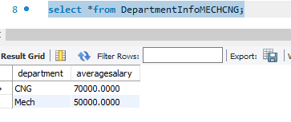**we can see that the privilege is garnted to passive user

***4) You want to authorize your assistant (DreamAssistant) to five people (you will probably tell him who to fire, but you want to be able to delegate this task), to check on who is an employee, and to check on average department salaries. What privileges should you grant?***

**  
we create a DreamAssistant account**



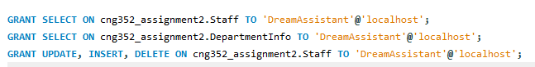

We make sure it gets the right to see staff, to see avg salaries and to be able to delete an employee or update things.

Let’s test it using DreamAssistant account  
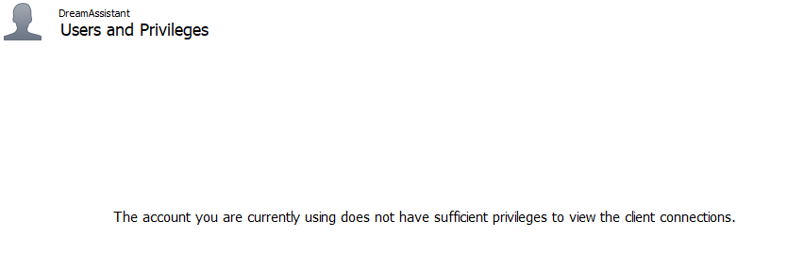

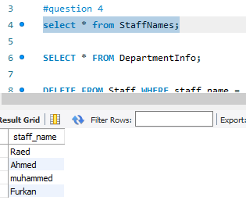

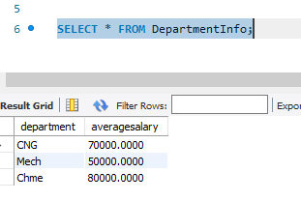



  
We can see that the dreamassistant can fire an employee  
  
Note: SET SQL_SAFE_UPDATES=0; has been used to be able to delete

***5) Continuing with the preceding scenario, you want your assistant to be able to look at the salaries of individuals. Does your answer to the previous question ensure this? Be specific: Can your assistant possibly find out salaries of some individuals (depending on the actual set of tuples), or can your assistant always find out the salary of any individual that he wants to?***

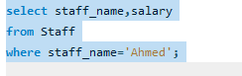



#we can see that the DreamAssistant doesn't have access to staff table, instead he can actually access

#the views that we created => he won't be able to see the salaries of individuales.

***6)You want to give your assistant the authority to allow other people to read the StaffNames view. Show the appropriate commands***



Now let’s check if the dreamassistant can allow passiveuser to access the view

  
dreamassistant gives the privilege to passiveUser  
  
-----------------------------

Now let’s check if passive user can access staffNames view  
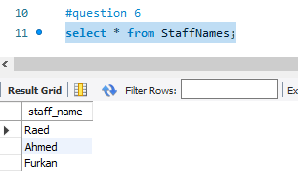  
that means passive User could get the privilege from DreamAssistant

***7) Your assistant defines two new views using the StaffNames view. The first is called AtoRNames and simply selects names that begin with a letter in the range A to R. The second view is called HowManyNames and counts the number of names. You are so pleased with this achievement that you decide to give your assistant the right to insert tuples into the StaffNames view. Show the appropriate command, and describe what privileges your assistant has after this command is executed***

  
that the dreamassistant can create view  
  
  
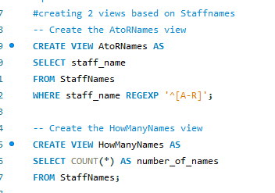  
  
it didn’t get the access to create view for some reason

***8) Your assistant allows DreamTodd to read the StaffNames relation and later quits. You then revoke the assistant's privileges. What happens to DreamTodd's privileges?***

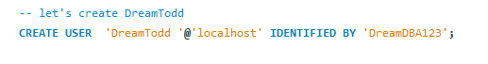

In DreamAssistant we give the privilege to dreamtodd  


Let’s check dreamTodd account  
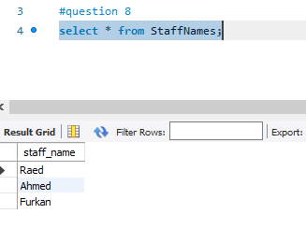  
that means it can access staffNames view  
  
=>  
let’s revoke it from DreamAssistant

  
  
but still DreamTodd can access the stafnames view  
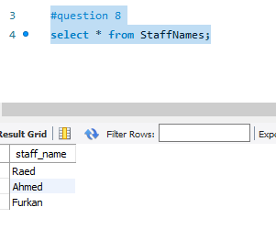  
after revoking  
  
  
  
  
  
  
  
  
  
  
  
  
  
  
  
  
  
  
  
  
  
  
  
  
  
  
  
  
  
  
***9) You decide to go on an extended vacation, and to make sure that emergencies can be handled, you want to authorize your boss DreamBoss to read and modify the Staff relation and the StaffName relation (and DreamBoss must be able to delegate authority, of course, since he is too far up the management hierarchy to actually do any work). Show the appropriate SQL statements. Can DreamBoss read DepartmentInfo view?***

We create the dreamboss



We give DreamBoss the required privileges  
  
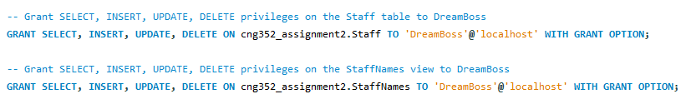

Let’s check DreamBoss account

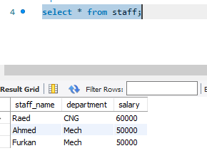

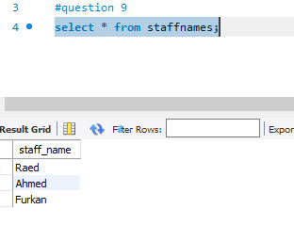  
  
  
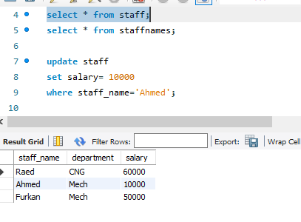  
we can see that Dreamboss can do update => he can do all other stuff related to the privileges granted

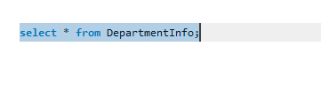

And we can see that DreamBoss can’t get the table of DepartmentInfo because he didn’t get the privilege to do so.

***10) After returning from your (wonderful) vacation, you see a note from DreamBoss, indicating that he authorized his assistant DreamBossAsist to read the Staff relation. You want to revoke DreamBossAsisst's SELECT privilege on Staff, but you don't want to revoke the rights that you gave to DreamBoss, even temporarily. Can you do this in SQL***

First we create dreambossAsist

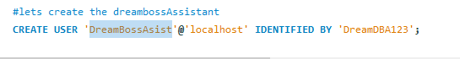

we give the privileges to dreambossAsist in DreamBoss



Let’s check DreamBossAsist

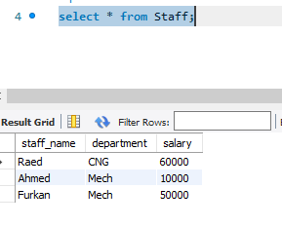  
we can see that it can access the Staff table

Now let’s revoke it directly from the DREAMDBA



Now let’s check DreamBoss and then DreamBossAsist  
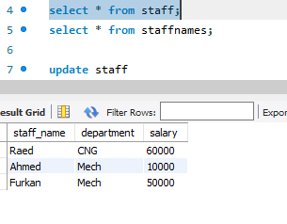  
we can see that DreamBoss can access Staff

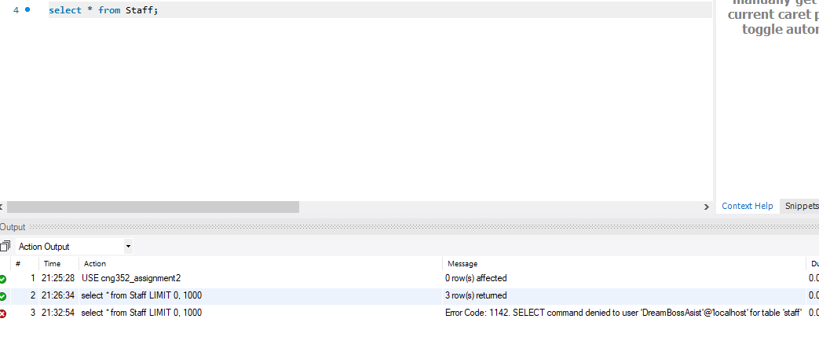  
while DreamBossAsist access is denied.

* It is possible to revoke from grandchild without affecting the child

***11) Later you realize that DreamBoss has been quite busy. He has defined a view called AllNames using the view StaffNames, defined another relation called EmployeeNames that he has access to (but that you cannot access), and given his assistant DreamBossAssist the right to read from the AllNames view. DreamBossAssist has passed this right on to his friend Susan. You decide that even at the cost of annoying DreamBoss by revoking some of his privileges, you simply have to take away DreamBossAsisst and Susan's rights to see your data. What REVOKE statement would you execute? What rights does DreamBoss have on Staff after this statement is executed? What views are dropped as a consequence?***

I grant the privilege to create View to dreamBoss



DreamBoss creates a view

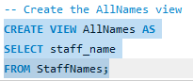

DreamBoss create a table

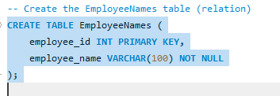



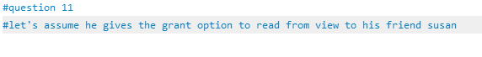

GRANT SELECT ON cng352_assignment2.AllNames TO 'Susan'@'localhost';

* Now we have to revoke privileges from susan and DreamBossAsist
* REVOKE SELECT ON cng352_assignment2.AllNames FROM 'DreamBossAssist'@'localhost';
* REVOKE SELECT ON cng352_assignment2.Staff FROM 'DreamBossAssist'@'localhost';
* REVOKE SELECT ON cng352_assignment2.AllNames FROM 'Susan'@'localhost';
* REVOKE SELECT ON cng352_assignment2.Staff FROM 'Susan'@'localhost';

By executing the above **REVOKE** statements, I ensure that DreamBossAssist and Susan no longer have access to the **AllNames** view and the **Staff** table. DreamBoss retains his privileges on these objects. This method does not drop any views but removes the specific access rights for DreamBossAssist and Susan.

***Thanks so much for reading the report  
it was good practice to discover MYSQL workbench***

***☺***